Ethical Machine Learning Research Student Researcher Capstone Project Ethics Form

As a student researcher in the capstone project, you are vital in ensuring the project is conducted ethically and without bias. Before you embark on the capstone project, please carefully read and understand the following information.
By conducting the capstone project, you will be actively engaged in the following research activities:
- Data analysis and preprocessing.
- Training and evaluating machine learning models.
- Drawing conclusions on the machine learning models and the dataset, nothing else.
The capstone project will comprehensively examine machine learning models without introducing biases or negatively affecting vulnerable populations in society. The focus is on improving the fairness and accuracy of the results obtained from the machine learning models. The focus is on the models themselves and the dataset without delving into social work, bias or anthropology. Use deductive reasoning on the model outcomes.
Yes | No | As a student researcher, your responsibilities include:
Yes |  | Adhering to ethical guidelines provided for data handling and analysis.
Yes |  | Data is anonymised, and personal identifiers will be removed to protect the privacy of individuals.
Yes |  | Ensure that the research does not introduce bias and avoids adverse effects on the vulnerable in society and minors.
Yes |  | Focus on evaluating and improving machine learning model accuracy and results.

I have read and understood the information provided in this ethics form, and I agree as a student researcher to abide by the ethics outlined in this form in the capstone project. I understand that my role will focus on machine learning models and dataset analysis and will not involve social work, health and care, vulnerable social groups or anthropology (no personal interviews of human subjects).
If you have any questions or concerns or require clarification on the capstone project's ethics, please contact James Garza at jgarza@cct.ie.

Student Name (printed): Lourdes Herrera

Student Number: sba25206

Student Signature: 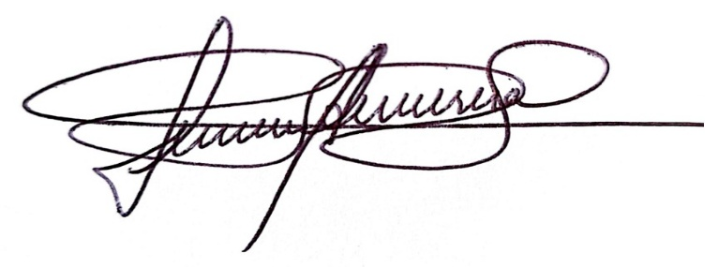

Date: 25/10/2026

